|  |
| --- |
| APTECH APROTRAIN |
| E-PROJECT 4 REPORT |
| Today News |
|  |

|  |  |  |  |  |  |  |  |  |  |  |  |  |  |  |
| --- | --- | --- | --- | --- | --- | --- | --- | --- | --- | --- | --- | --- | --- | --- |
| |  |  |  | | --- | --- | --- | | Member | VU TRAN QUANG | Student1141700 | |  | KHOI NGUYEN DAM | Student1139856 | |  | LONG NGUYEN THE | Student1141702 | |  |  |  | |  |  |
|  |  |  |
|  |  |  |

|  |
| --- |
| Any information in this report which includes the content in this website is used for uncommercial purposes. |

**MENU**

**I.** **Introduction** 3

**1.** **Project information** 3

**2.** **Problem statement** 3

**3.** **Propose System** 3

**4.** **Hardware/ Software Requirements** 3

**II.** **Acknowledgements** 4

**III.** **System Design** 5

**IV.** **Screen shots at user’s client site** 10

1. **Homepage articles listing** 10

V. **Screen shot of Admin’s site** (vutran – 123) 15

**VI.** **Source Code:** 19

**VII.** **Task Sheet:** 19

1. **Introduction**
2. **Project information**

Project name: Today News

Project type: Website

Timeline: from 12-Jun-2021 to 10-July-2021

1. **Problem statement**

Today News portal allows customers to read up to date news like entertainment, national news, international news, business related and sports etc.

User can also contact us to give suggestions and can also give us feedback related to our sit. New article can be added only by the admin and only admin have the right to update or delete any article.

Admin have the right to give authority to other for news update, add or delete. The traditional media rooms all around the world are fast adapting to the new age technologies. This marks the beginning of news portals by media houses across the globe.

This new media channels give them the opportunity to reach the viewers in a shorter span of time than their print media counterparts

1. **Propose System**

* Article listing
* Popular article listing
* Articles by category listing
* Comment/feedback
* Checking Availability
* Making Reservations/Blocking/Confirmation
* CRUD new article
* CRUD new category
* Managing comments
* Login/Signup

1. **H****ardware/ Software Requirements**

**Hardware**

* A minimum computer system that will help you access all the tools in the courses is a Pentium 166 or better
* 64 Megabytes of RAM or better

**Software**

* NetBeans
* MySQL

1. **Acknowledgements**

We would like to send our sincere thanks to:

- The Aptech training system has provided the topic as well as support in many aspects of our project process.

- Faculty Nguyen Ngoc Duy, who had given us a lot of support, guidance, motivation throughout the project, from the beginning till the very end.

1. **System Design**

**Database design**

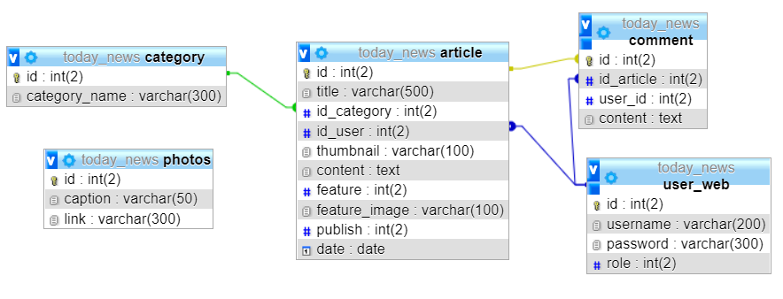

**Table’s details**

Table **Category**

|  |  |  |  |
| --- | --- | --- | --- |
| **Column** | **Data type** | **Constraint** | **Description** |
| id | Int(2) | NOT NULL  PRIMARY KEY  AUTO_INCREMENT | Unique ID to define category |
| category_name | varchar(300) | NOT NULL | Name of the category |

Table **photos**

|  |  |  |  |
| --- | --- | --- | --- |
| **Column** | **Data type** | **Constraint** | **Description** |
| id | int(2) | NOT NULL  PRIMARY KEY  AUTO_INCREMENT | Unique ID to define each image |
| caption | varchar(50) | NOT NULL | Image caption |
| link | varchar(300) | NOT NULL | Link to the image |

Table **‘user_web’**

|  |  |  |  |
| --- | --- | --- | --- |
| **Column** | **Data type** | **Constraint** | **Description** |
| id | int(2) | NOT NULL PRIMARY KEY  AUTO_INCREMENT | Unique ID to define each user |
| username | varchar(200) | NOT NULL  FOREIGN KEY | Username |
| password | varchar(300) | DEFAULT NUL | Account password |
| role | int(2) | DEFAULT NULL | Role of user |

Table ‘**article**’

|  |  |  |  |
| --- | --- | --- | --- |
| **Column** | **Data type** | **Constraint** | **Description** |
| id | int(2) | NOT NULL  PRIMARY KEY  AUTO_INCREMENT | Unique id to identify an article |
| title | varchar(500) | NOT NULL | Title of article |
| id_category | int(2) | NOT NULL | Id of category that the article belong to |
| id_user | int(2) | NOT NULL  FOREIGN KEY | Id of user who write the article |
| Thumbnail | varchar(100) | NOT NULL | Image link of the article thumbnail |
| content | Text | Not null | The content of the article |
| Feature | int(2) | DEFAULT NULL | Settings for article to be a featured post |
| publish | int(2) | DEFAULT NULL | Settings for article to be published |
| Date | Date | NOT NULL | Publish date of the particle |

Table ‘**comment**’

|  |  |  |  |
| --- | --- | --- | --- |
| **Column** | **Data type** | **Constraint** | **Description** |
| id | Int(2) | PRIMARY KEY  NOT NULL  AUTO_INCREMENT | Unique ID to identify a comment |
| Id_article | Int(2) | NOT NULL  FOREIGN KEY | Id of article that the comment belongs to |
| User_id | Int(2) | NOT NULL  FOREIGN KEY | Id of user that writes the comment |
| content | text | NOT NULL | Comment’s content |

**User Diagram**

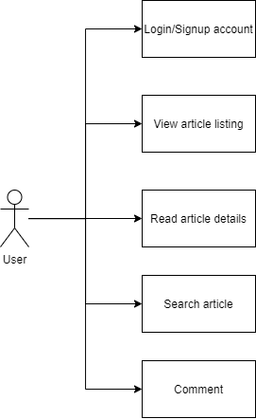

**Backend user Diagram**

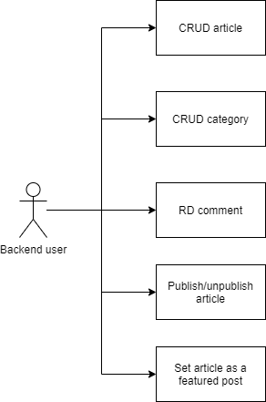

1. **Screen shots at user’s client site**

**Homepage articles listing**

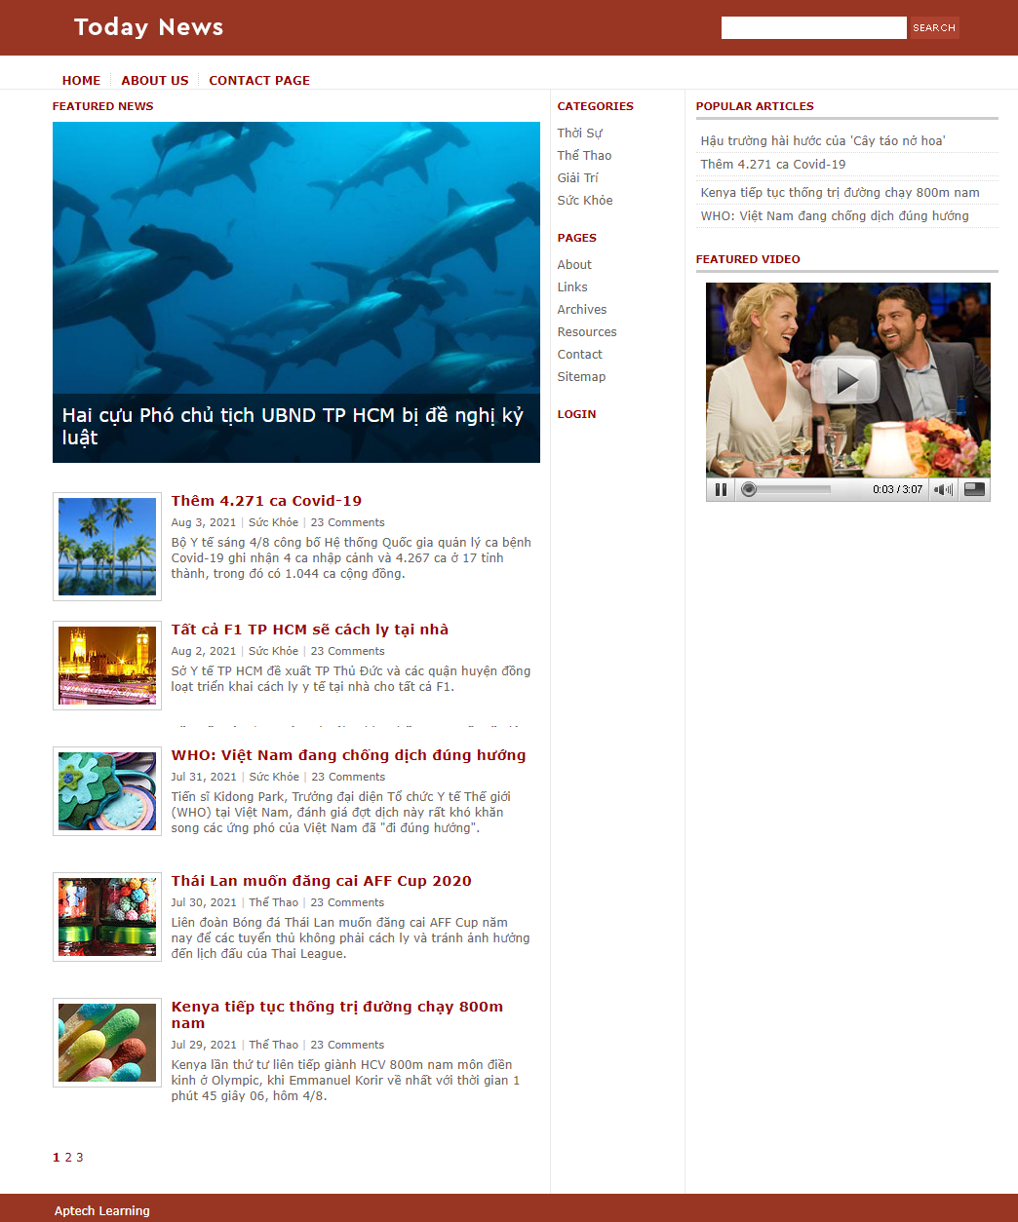

**Category articles listing**

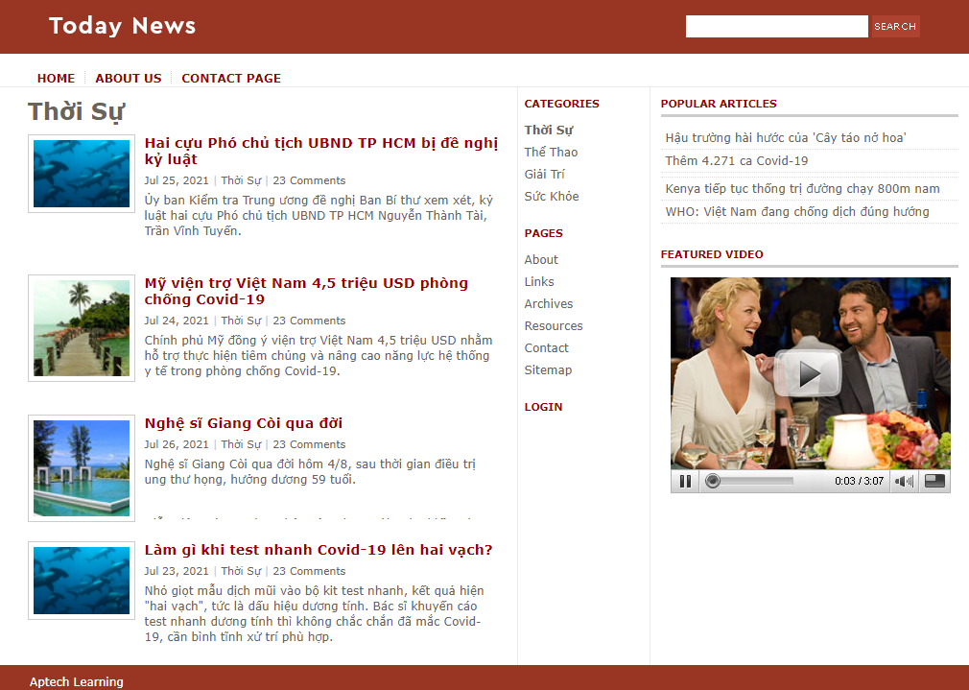

**Article details**

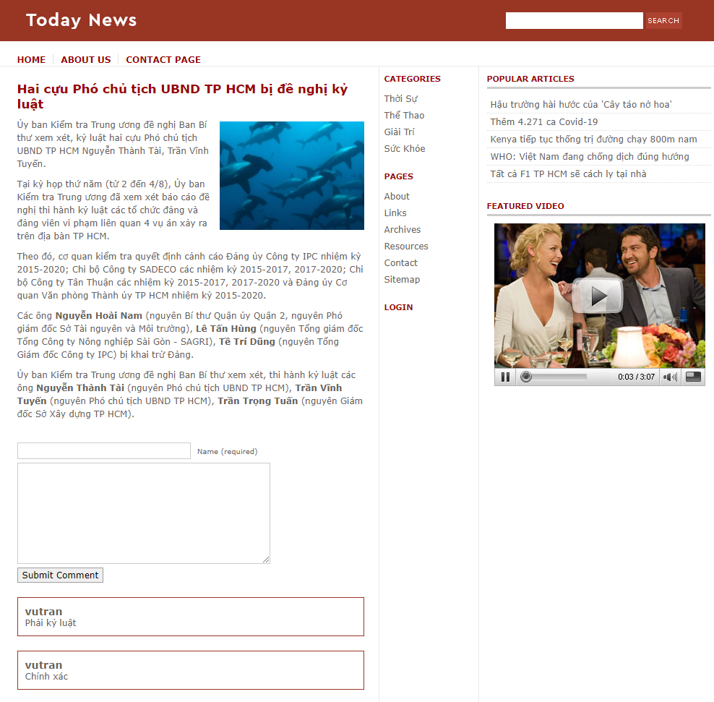

**Articles search results**

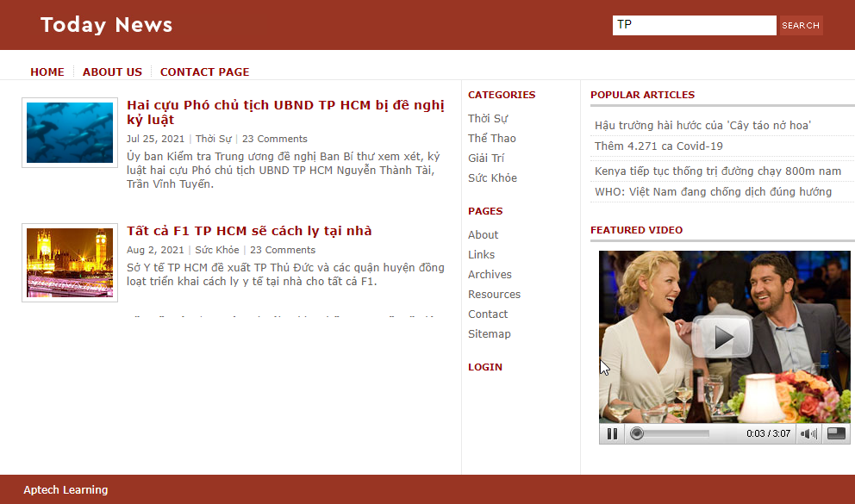

**Sign in/Sign up**

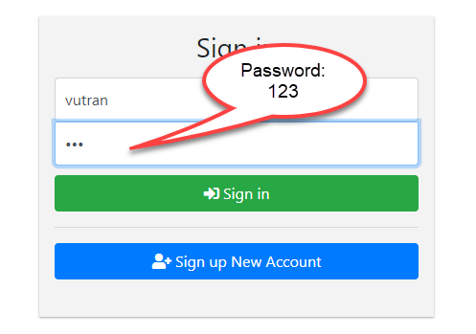

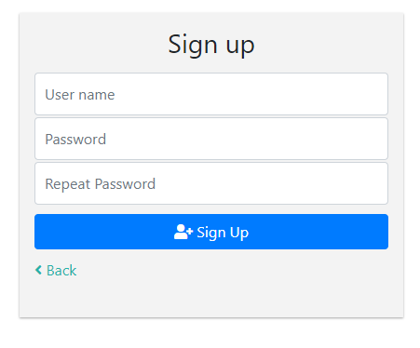

1. **Screen shot of Admin’s site** (vutran – 123)

**Manage articles**

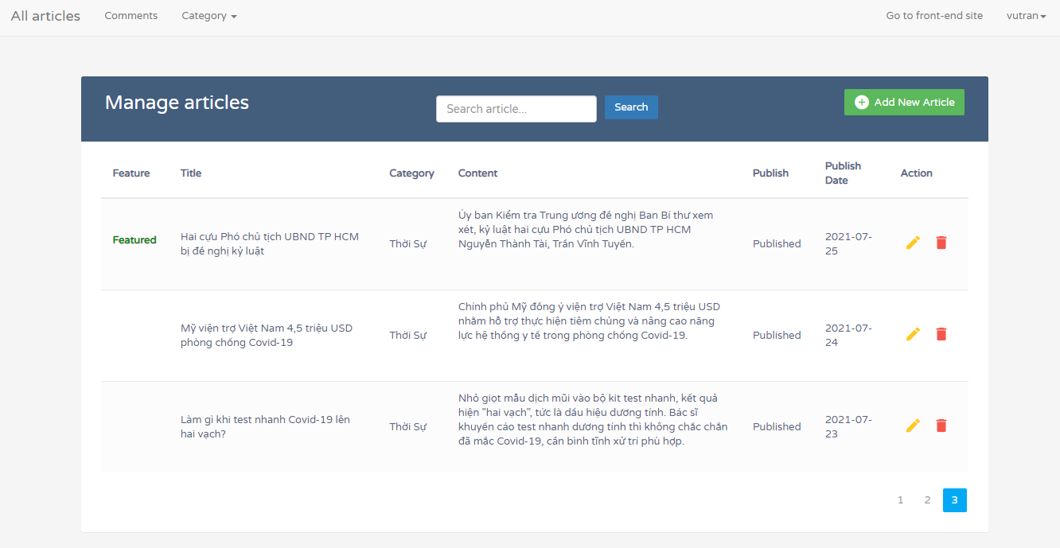

**Add new article**

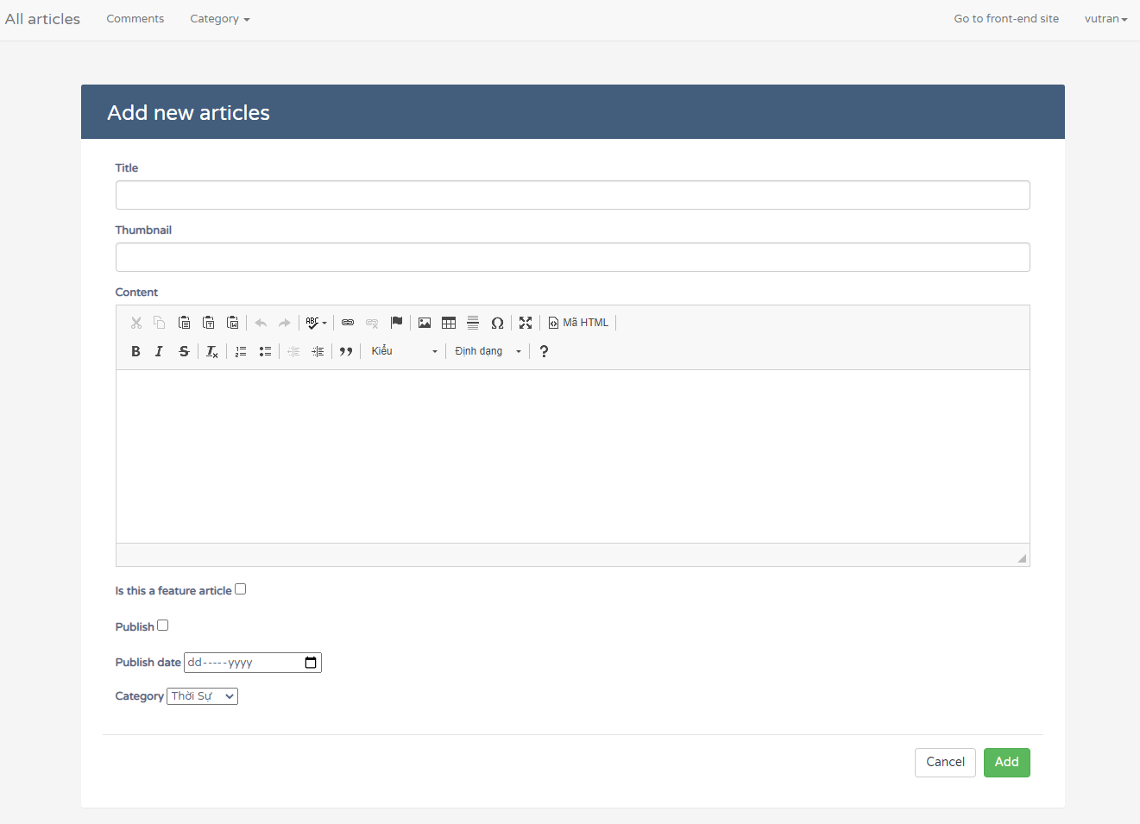

**Edit article**

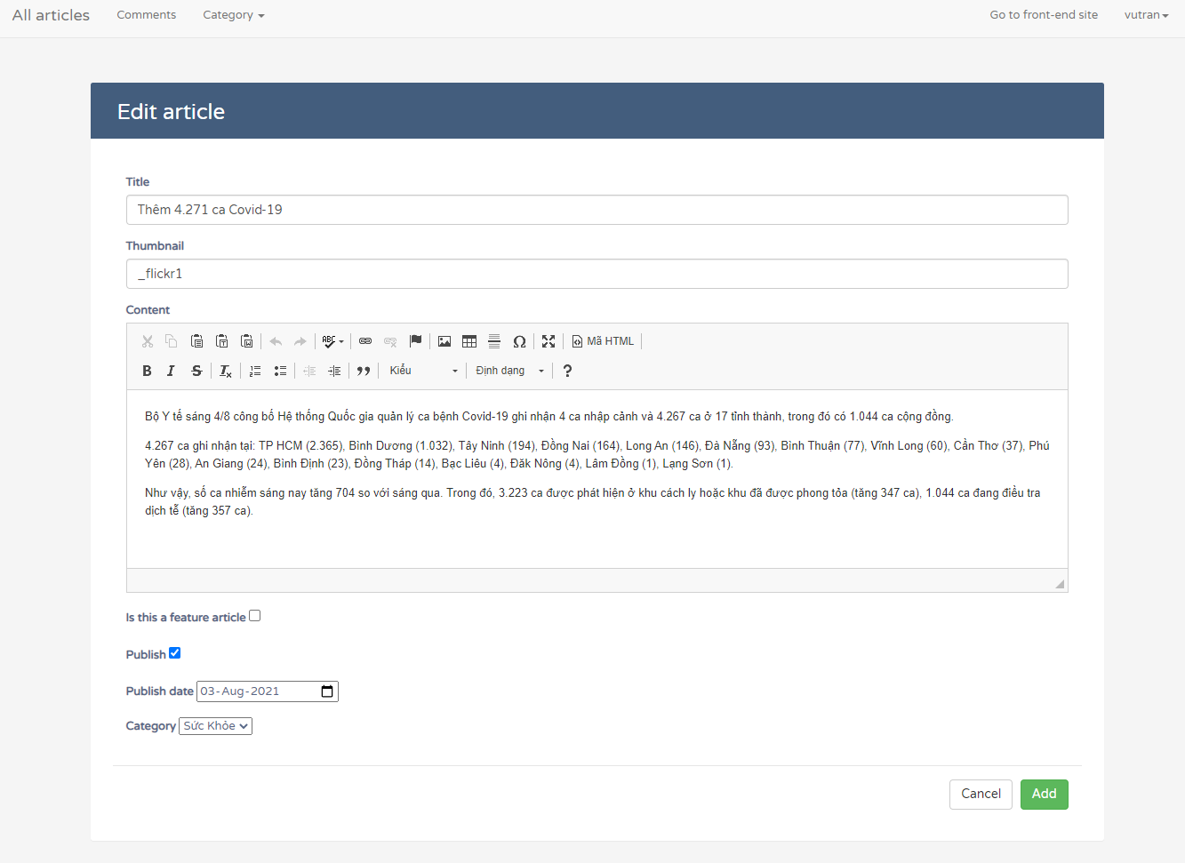

**Delete article**

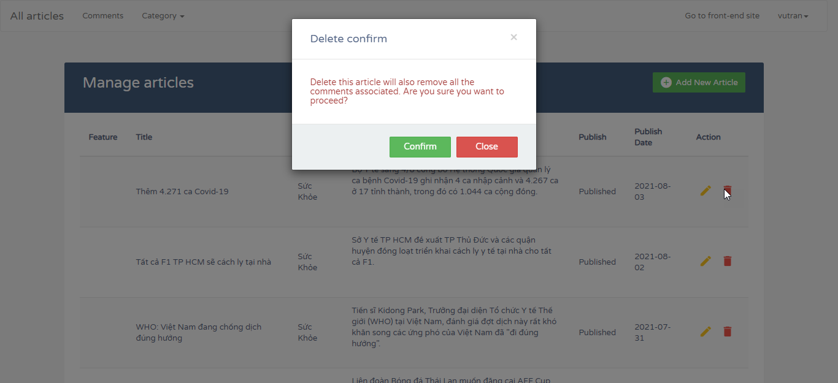

**Manager category**

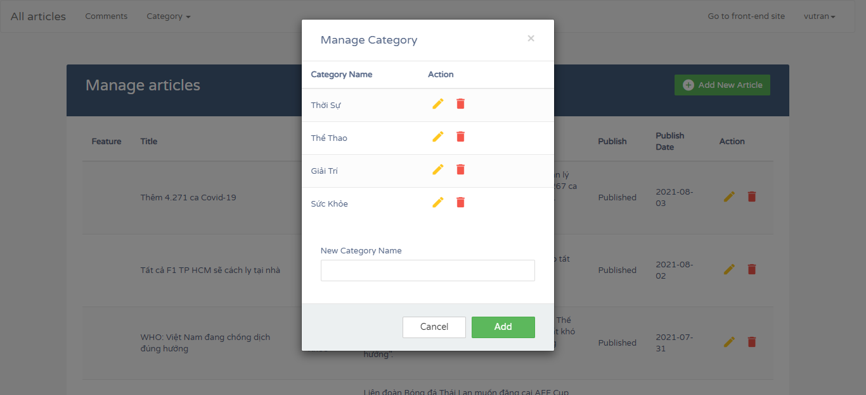

**Edit category**

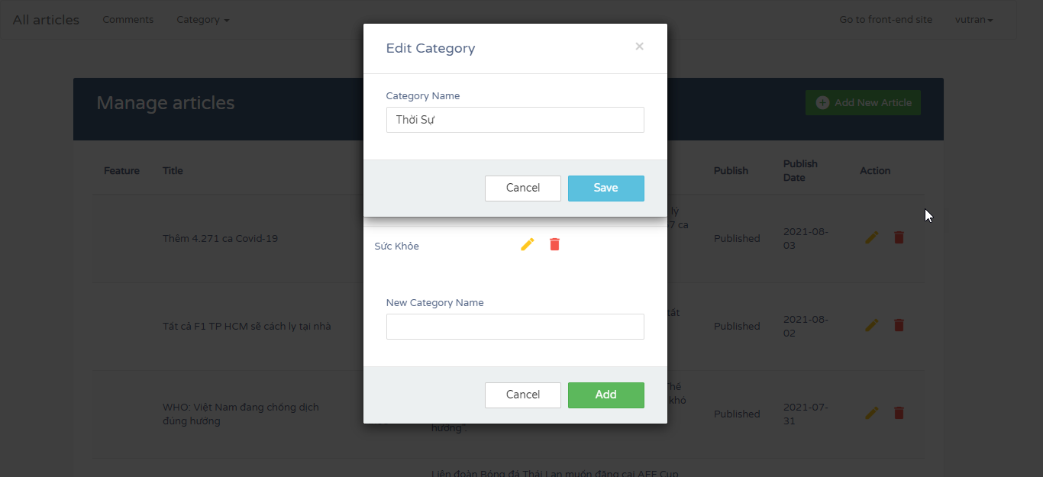

**Delete category**

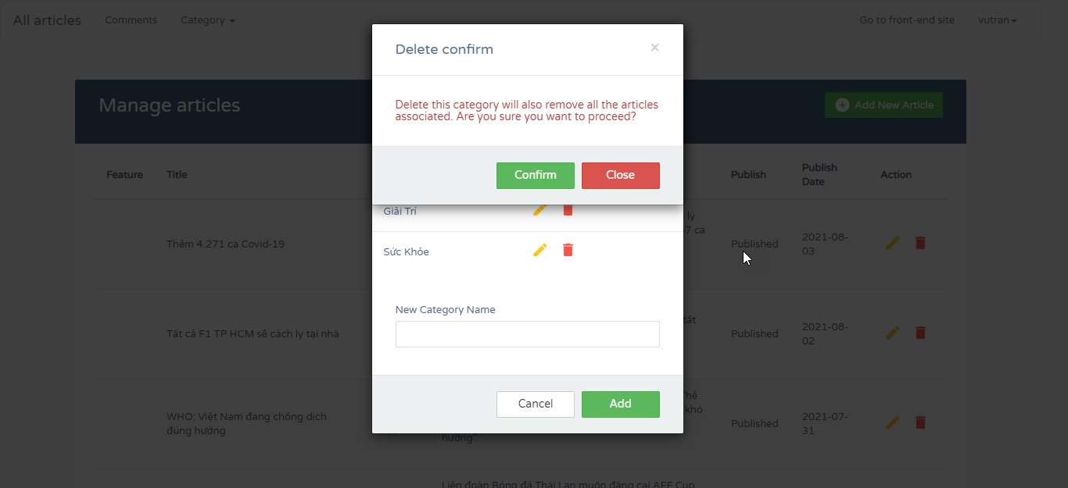

**Manage comments**

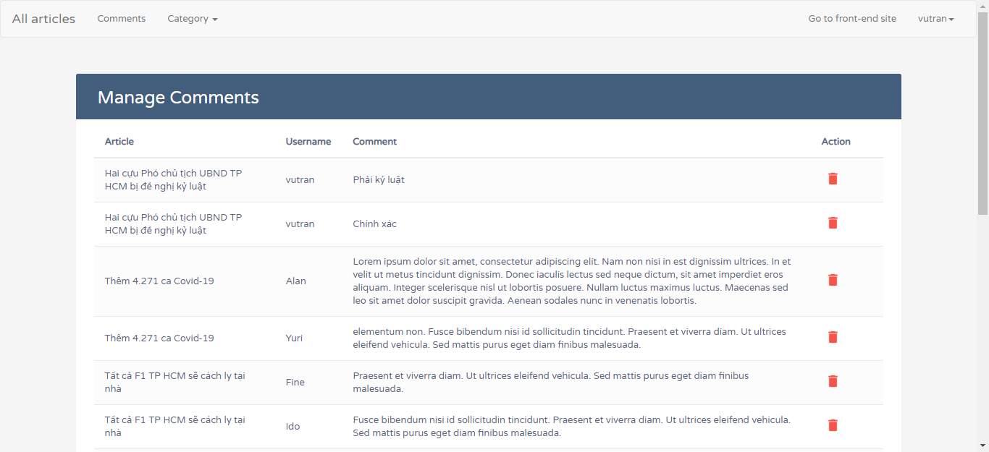

1. **Source Code:**

All parts of our project source code have been compressed and uploaded to google drive under the link below. Please download the link.

1. **Task Sheet:**

|  |  |  |  |  |
| --- | --- | --- | --- | --- |
| 1. Task | Start time | Finish time | Implemented by | Evaluation(%) |
| Feasibility study phase |  |  |  |  |
| Evaluate and analyze idea | 12/06/2021 | 14/06/2021 | VU TRAN QUANG | 30 |
| Provide opinions and idea | 12/06/2021 | 14/06/2021 | KHOI NGUYEN DAM | 25 |
| Provide opinions and idea | 12/06/2021 | 14/06/2021 | LONG NGUYEN THE | 25 |
| Approve and finalize idea | 15/06/2021 | 15/06/2021 | VU TRAN QUANG | 20 |
| Requirement Analysis phase |  |  |  |  |
| Propose system | 16/06/2021 | 16/06/2021 | KHOI NGUYEN DAM | 50 |
| Analyze and approve final system | 18/06/2021 | 18/06/2021 | VU TRAN QUANG | 50 |
| Design phase |  |  |  |  |
| Design Database | 19/06/2021 | 21/06/2021 | VU TRAN QUANG | 50 |
| Design basic static client and admin | 19/06/2021 | 21/06/2021 | LONG NGUYEN THE | 50 |
| Development phase |  |  |  |  |
| Client site – Home Page, Paging | 21/06/2021 | 23/06/2021 | VU TRAN QUANG | 20 |
| Client site – Search, Category | 21/06/2021 | 23/06/2021 | LONG NGUYEN THE | 10 |
| Client site – Detail page, Comment function, Popular post. | 23/06/2021 | 27/06/2021 | VU TRAN QUANG | 10 |
| Client site – Login/Signup | 21/06/2021 | 22/06/2021 | KHOI NGUYEN DAM | 10 |
| Admin site – Manage category | 22/06/2021 | 26/06/2021 | KHOI NGUYEN DAM | 10 |
| Admin site – Manage article | 27/06/2021 | 31/06/2021 | VU TRAN QUANG | 20 |
| Admin site – Manage comment | 23/06/2021 | 27/06/2021 | LONG NGUYEN THE | 10 |
| Admin site – Login/Logout/Anonymous user | 27/06/2021 | 31/06/2021 | KHOI NGUYEN DAM | 10 |
| Testing phase – Delete page |  |  |  |  |
| Testing client site | 01/07/2021 | 03/07/2021 | KHOI NGUYEN DAM | 30 |
| Testing admin site | 01/07/2021 | 03/07/2021 | LONG NGUYEN THE | 30 |
| Final testing, fixing bugs | 04/07/2021 | 05/07/2021 | VU TRAN QUANG | 40 |
| Deployment phase |  |  |  |  |
| Analyze and approve final product | 06/07/2021 | 10/07/2021 | LONG NGUYEN THE | 50 |
| Write product report | 11/07/2021 | 15/07/2021 | VU TRAN QUANG | 50 |